

CONTINUING EDUCATION PROGRAM

CENTER FOR COMPUTING AND INFORMATION TECHNOLOGY

FACULTY OF ENGINEERING UNIVERSITY OF INDONESIA

SCHOOL INFORMATION SYSTEM

Member :

1. Muhammad Hudya Ramadhana
2. Mutia Ayu Dianita
3. Radityo Harimurti

Class : 1SC2 (PNJ)

Group : 2

Faculty : M. Octaviano Pratama S.St

**Project On School Information System**

Developed by :

1. Muhammad Hudya Ramadhana
2. Mutia Ayu Dianita
3. Radityo Harimurti

**School Information System**

Batch Code : (1SC2)

Start Date : November 24th, 2015 End Date : December 2nd, 2015

Name of the Coordinator : Mr. M. Octaviano Pratama

Name of Developer :

1. Muhammad Hudya Ramadhana
2. Mutia Ayu Dianita
3. Radityo Harimurti

Date of Submission : November th,2015

**NIIT**

**Certificate**

This is to certify that this report titled School Information System embodies the original work done by Muhammad Hudya Ramadhana, Mutia Ayu Dianita and, Radityo Harimurti in partial fulfillment of their course requirement at NIIT.

Coordinator :

Mr. M. Octaviano Pratama

**ACKNOWLEDGEMENT**

Writer have benefited a lot from the feedback and suggestions given to us by **Mr. M. Octaviano Pratama S.St** and other faculty members. Writer make this project to fulfill our assignment.

Writer make this project with see the basic of School Information System and make it with our own style.

Writer said Alhamdulillah to Allah S.W.T because of his blessing, writer can complete this project.

Writer know this paper is far from perfection. Writer hope if writer friend and writer faculty give any comment and suggestion to make this paper better than before.

Writer also said thankyou to :

1. Our Family who give many support to make this paper completed.
2. Mr. M. Octaviano Pratama S.St as the guide’s lecturer that give put together with the suggestion, idea & constructive spirit to make this project better.
3. Our Friends who give many idea, spirit and comment to our project.

If the writer made a mistake in writing the application of this School Information System, Writer ask forgive to all reader and listener of this paper.

Depok, 25 November 2015

**SYSTEM ANALYSIS**

System Summary :

SIS or School Information System is a system to keep the record of the student,employee, class,majoring, and course. School Information System is a web based system which student or employee can access the website and check their data. Student also can check their class, majoring and their course.

System Process:

SIS will keep information such as the student as in their id,name,sex, address and phone number. The information can be accessed by admin and the student with a password.

Admin can input the course and manage all data about school. Each Treasurer can store the data about student payment.

The student entity is connected to the class they follow which consist of id at the class, name of the class and id of the headclass. Each Class has majoring consist of id_majoring and name of major. Each Major has course consist of id course , and name which will be input by admin. Each student will pay fee to the Treasurer. Class will be teach by teacher with id of the subject teacher, treasurer, admin will be generailized in the employee which consist of name,birhtdate sex,id employee, address,phone number.

The student has many parents (more than one or can only one), but every parents also has many students (more than one or can only one). Each Student is registered in one class, but one class can have many students. Class also can be teached by many teacher, but every Class only have one majoring. Majoring have many course, but some of course is registered only to one majoring.

**ENTITIES**

Number of Entities : 9

Names of Entities :

1. Student
2. Majoring
3. Course
4. Class
5. Parents
6. Teacher
7. Treasurer
8. Admin
9. Employee

**ATTRIBUTES**

**Attributes :**

The various Entitles and their attributes are listed in the following table :

|  |  |
| --- | --- |
| **ENTITIES** | **ATTRIBUTES** |
| Student | Id_student |
|  | Password |
|  | Name |
|  | Sex |
|  | Birthdate |
|  | Address |
|  | phone |
| Class | Id_class |
|  | Name |
|  | Id_headclass |
| Parents | Name |
|  | Address |
|  | Phone |
| Majoring | Id_majoring |
|  | Name |
| Course | Id_course |
|  | Name |
| Teacher | Id_subject |
| Employee | Id_employee |
|  | Password |
|  | Name |
|  | Sex |
|  | Birthdate |
|  | Address |
|  | Phone |

**ENTITIES RELATIONAL DIAGRAM**

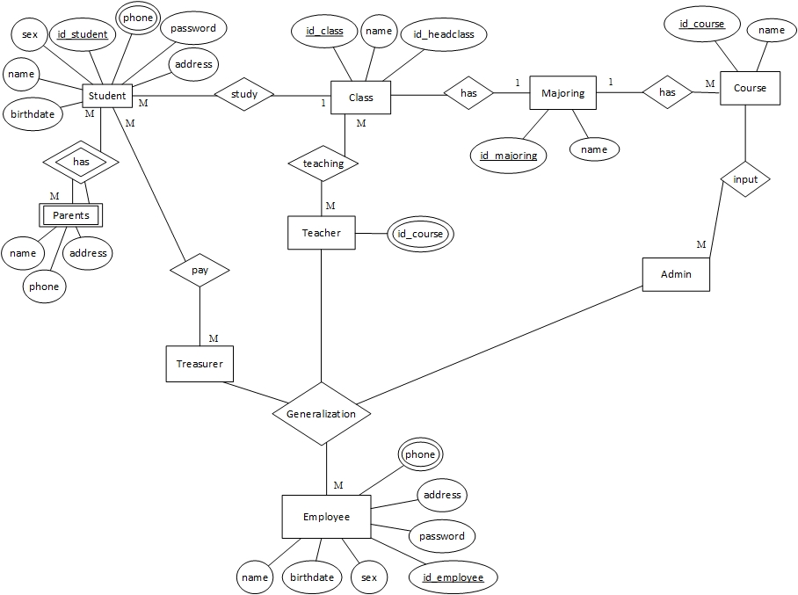

**TABLES**

Number of Tables : 7

Structure of Tables : The Table structures are shown here.

Employee (Entity)

Student (Entity)

|  |
| --- |
| Student |
| Id_student |
| Password |
| Name |
| Sex |
| Birthdate |
| Address |
| Phone |

|  |
| --- |
| Employee |
| Id_employee |
| Password |
| Name |
| Sex |
| Birthdate |
| Address |
| Phone |

Course (Entity)

Majoring (Entity)

Parents (Entity)

|  |
| --- |
| Parents |
| Name |
| Address |
| phone |

|  |
| --- |
| Majoring |
| Id_majoring |
| Name |

|  |
| --- |
| Course |
| Id_course |
| Name |

Class (Relationship)

|  |
| --- |
| Teacher |
| Id_course |

|  |
| --- |
| Class |
| Id_class |
| Name |
| Id_headclass |

Teacher (Entity)

**NORMALIZATION**

Abnormal Table

1NF

FD1

|  |  |
| --- | --- |
| Id_student | |
| Password | |
| Name | |
| Sex | |
| Birthdate | |
| Address | |
| Phone | |
| Id_employee | |
| Password | |
| Name | |
| Sex | |
| Birthdate | |
| Address | |
| Phone | |
| Name | |
| Address | |
| phone | |
| Id_majoring | |
| Name | |
| Id_course | |
| Name | |
| Id_class | |
| Name | |
| Id_headclass | |
| Id_course |

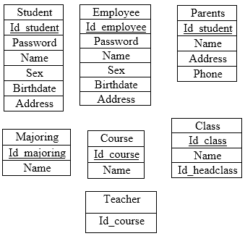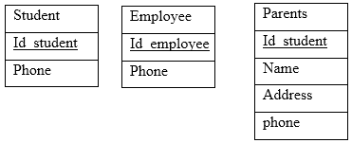

2NF

FD6

FD5

FD4

FD3

FD2

**TABLES AFTER 1NF**

Structure of Tables : The Table structure are shown here.

|  |  |
| --- | --- |
| Id_student | |
| Password | |
| Name | |
| Sex | |
| Birthdate | |
| Address | |
| Id_employee | |
| Password | |
| Name | |
| Sex | |
| Birthdate | |
| Address | |
| Name | |
| Address | |
| Id_majoring | |
| Name | |
| Id_course | |
| Name | |
| Id_class | |
| Name | |
| Id_headclass | |
| Id_course |



Note:

Telephone entity created as a requirement that must be met for the method 1 NF. Because in 1NF method should not be multivalued.

**TABLES AFTER 2NF**

Structure of Tables : The Table structure are shown here.

Note:

Entity Student,Employee, Parents, Majoring, Course, Class,Teacher was made because it is a requirement that must be met for a second method 2 NF.



**MAPPING TABLE METHOD**

|  |  |  |  |  |  |  |
| --- | --- | --- | --- | --- | --- | --- |
| ID_STUDENT | NAME | SEX | BDATE | ADDRESS | PHONE | ID_CLASS |

STUDENT

|  |  |  |  |
| --- | --- | --- | --- |
| ID_STUDENT | NAME | ADDRESS | PHONE |

PARENTS

|  |  |  |  |
| --- | --- | --- | --- |
| ID_CLASS | NAME | ID_HEADCLASS | ID_MAJORING |

|  |  |
| --- | --- |
| ID_MAJORING | NAME |

|  |  |  |
| --- | --- | --- |
| ID_COURSE | NAME | ID_MAJORING |

|  |  |  |  |  |  |  |
| --- | --- | --- | --- | --- | --- | --- |
| ID_EMPLOYEE | NAME | SEX | BDATE | ADDRESS | PHONE | TYPE |

|  |  |  |
| --- | --- | --- |
| ID_EMPLOYEE | NAME | ID_COURSE |

|  |  |
| --- | --- |
| ID_EMPLOYEE | NAME |

|  |  |
| --- | --- |
| ID_EMPLOYEE | NAME |

TREASURE

ADMIN

TEACHER

STAFF

COURSE

MAJORING

CLASS

**MAPPING TABLE METHOD**

Structur of Tables : The Table structure areshown here.

|  |
| --- |
| Student |
| Id_student |
| Password |
| Name |
| Sex |
| Birthdate |
| Address |
| Phone |

|  |
| --- |
| Employee |
| Id_employee |
| Password |
| Name |
| Sex |
| Birthdate |
| Address |
| Phone |

|  |
| --- |
| Class |
| Id_class |
| Name |
| Id_headclass |

|  |
| --- |
| Parents |
| Name |
| Address |
| phone |

|  |
| --- |
| Teacher |
| Id_course |

|  |
| --- |
| Majoring |
| Id_majoring |
| Name |

|  |
| --- |
| Course |
| Id_course |
| Name |

**PROBLEMS ENCOUNTERED**

Some of the problems experienced in the writing of the inventor of this project are as follows :

* We have just learned about normalization and we still have some of mistake when make normalization
* Difficult to think an idea for creating entity and the attributes
* We still not well experienced make a project like this.

**HARDWARE**

**Hardware** : IntelR CoreTM i3-3217U CPU @ 1.80 GHz (4CPUs), 2.00GB RAM, 500 GB HDD, ASUS X450C 802.11b/g/n,6 cell Li-ion battery

**Operating System** : Windows 7 Ultimate

**Software** : Microsoft Visio 2013, Microsoft Office Word 2013

**PROJECT FILE DETAILS**

|  |  |  |
| --- | --- | --- |
| S.No | File Name | Remarks |
| 1 | School Information System.docx | MS Word 2013 |
| 2 | ERD.vsdx | MS Visio 2013 |